Training Slides & Assessment Prep


Training Deck Deep Dive & Assessments 🎓

Time to step into the shoes of an Onboarding Consultant and get cozy with the decks they use to guide our merchants. You've got 1 hour and 30 minutes to dive into the training materials, so grab your favorite beverage and let's get to it! ☕

What’s This About?

These training decks are designed to:
✅ Teach merchants how to navigate the BackOffice and POS Register like pros.
✅ Ensure they’re confident and ready before going live with StoreHub.

What You’ll Do:

- Master the Decks:Think of these slides as your secret weapon — by understanding them, you’ll be able to explain, guide, and impress merchants without breaking a sweat.

- Proactively Schedule Training: Once you’ve completed the Welcome Call, don’t wait — ask merchants for their available date and time to schedule their Onboarding Training with our Onboarding Consultants. Timing is everything!

- Spot the Upsell Opportunities: Pay attention! If you notice a merchant is missing resources or unaware of certain features, this is your chance to upsell and offer solutions that can help their business thrive. Bonus points if you wow them with your product knowledge! 💡

Why This Matters:

Understanding the training flow is key to helping merchants feel confident before they go live. When merchants are prepared and familiar with the system, they’re not just satisfied — they’re excited to use StoreHub. And when you understand the product well, it’s much easier to spot opportunities to upsell, suggest resources, and provide real value.

Pro Tip:
Take notes, ask questions, and make this training deck your new BFF. The better you know it, the smoother your conversations with merchants will be. Who knows? You might just discover your inner onboarding superstar. 🌟
Let’s get learning — the merchants are counting on you! 🚀

Step 1: Learn from the Masters 🏆

- Begin by watching video samples of your seniors in action.
- Observe how they ace merchant training—teaching merchants to navigate the system with ease and confidence.
- While you watch and read through the deck, take your own notes. Trust us, these notes will be your best friend later when you’re tested.

Video Samples:
Country | Deck |  | Video
MY | F&B | Retail | CN Version | EN Version
PH | Slide |  | PH Video

Pro Tip for Watching Videos 🎥💡

We know the videos might feel a bit lengthy, but don’t worry—you’ve got options!
- Speed things up: Play them at a higher speed to breeze through the content.
- Skip around: Jump to the sections you need to get the gist of the guide.

It’s all about making the most of your time while still getting the key takeaways. Happy watching! 🚀

Step 2: Put Your Knowledge to the Test 📝

Later in the day, you’ll be tested in a mock assessment with your coach. There will be 2 Training Assessments where you’ll showcase your training skills:

- Day 4 | 2:30 PM – 3:30 PM: F&B Training Assessment
- Day 4 | 4:00 PM – 5:00 PM: Retail Training Assessment

Here’s how the assessments will flow:

- First 30 minutes: You’ll conduct a mock training session using the checklist below; provide explanation and teach how to setup and the functions of each feature.
- Next 30 minutes: Your coach will provide feedback on your performance.

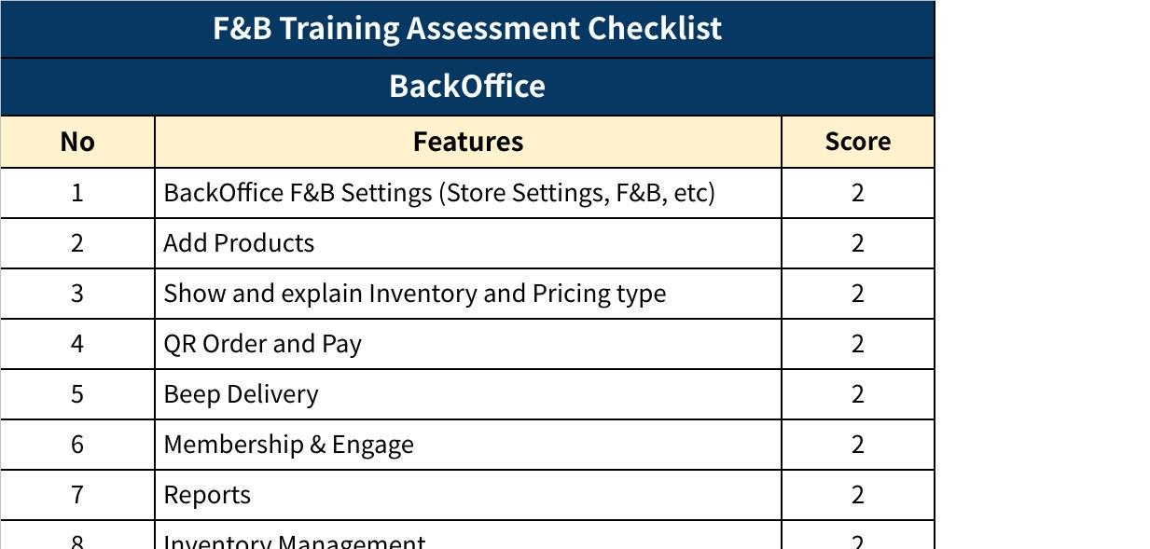
Click the image to view the sheet.
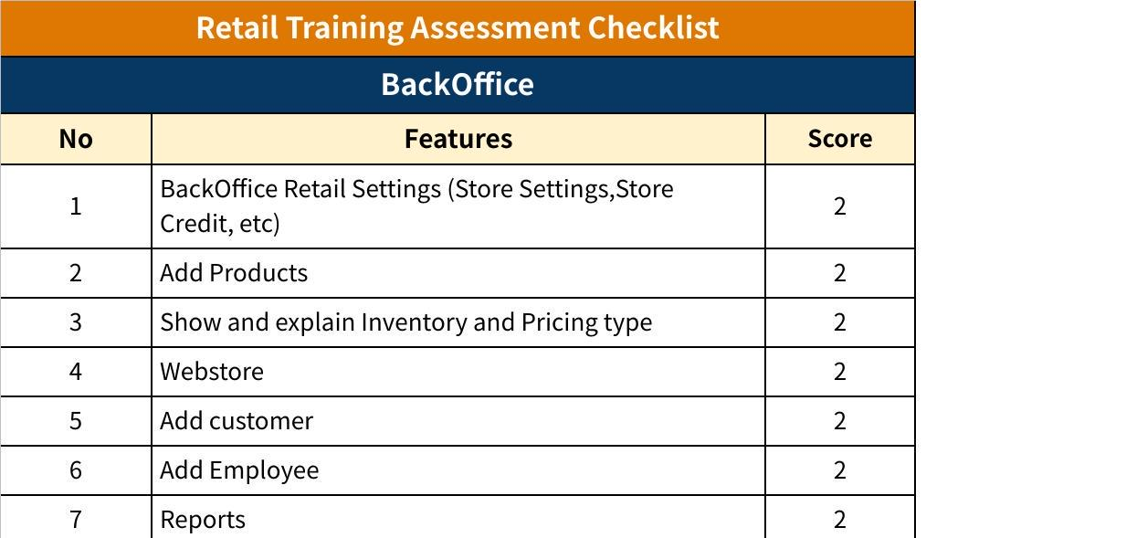
Click the image to view the sheet.

Important Tips for Success 🌟

- No Pressure: There won’t be a retake if you fail—but no worries, just have fun and stay natural.
- Be Engaging: Treat the session like it’s with real merchants. Smile, connect, and make it enjoyable.
- Be Prepared: Use the provided checklist to ensure you’ve covered all key points during your mock session.

All the best! Remember, this is your time to shine and prove you’ve got what it takes to rock the role. 🚀

